
Dert from Decomposer, a free one-knob distortion plugin
August 28, 2026 | info@decomposer.de | decomposer.de
Decomposer has released Dert, a free distortion plugin with exactly one control.
Most of the time you're not trying to dial in a particular distortion. You just want the thing dirtier. So that's all Dert gives you: one knob. Turn it up and the sound moves through overdrive, distortion, bitcrush and ring mod, each one crossfading into the next. No modes, nothing to set up, and no wrong way to set it. You turn it until it sounds right and get on with the track.
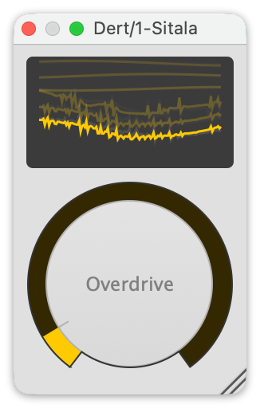
Dert: one knob, four kinds of dirt.
A little bit puts some grit on a snare. More across a whole kit and it sounds like it came off a worn record. Push it to the top and it stops being a mixing tool and starts being a musical one: ride the knob into a build, or kick it in for a bar ahead of the drop and pull it straight back out.
It's not fussy about what you feed it, either. Dert will fatten a bass line, rough up a vocal, or chew a synth pad to pieces.
It pairs naturally with Sitala, Decomposer's drum sampler. Sitala's the easiest-to-use drum sampler on the market; Dert's the easiest distortion effect.
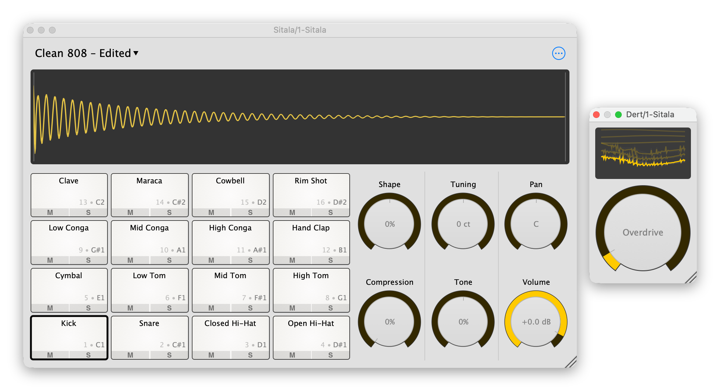
Dert running alongside Sitala, Decomposer's drum sampler.
Dert is free, and available as a VST, AudioUnit and AAX plugin for macOS and Windows at decomposer.de.

